**Design Document – *Bounce***

By: Ji Lin Z.

**Game Description**

***Bounce*** is a fun, relaxing and mostly skill-based game with an element of luck incorporated to make the game exciting as it is played. The objective of the game is simple; increase your score by hitting the green target with the ball. As your score increases, the target gets more and more difficult to hit. Keep hitting the targets to stay alive!

The player begins with four lives and stationary on the ground. The player must use the click and release of the left mouse button to aim and hit the target. If the target is hit by the ball, the player will gain a point and a life. If not, the player will lose a life and must reattempt to hit the target. In additional, three platforms will appear to aid or prevent the player from hitting the target. The green platform acts as a trampoline and helps keep the ball in motion. The red platform act as glue and causes the ball to stop, resulting in an instant loss of a life. The player must keep hitting the targets to gain points and keep their lives above zero.

**Instructions for Playing** ***Bounce***

Once “Bounce.py” is open in IDLE, press F5 to run the code. You will be presented with the following main menu screen containing two buttons, Play and Help.

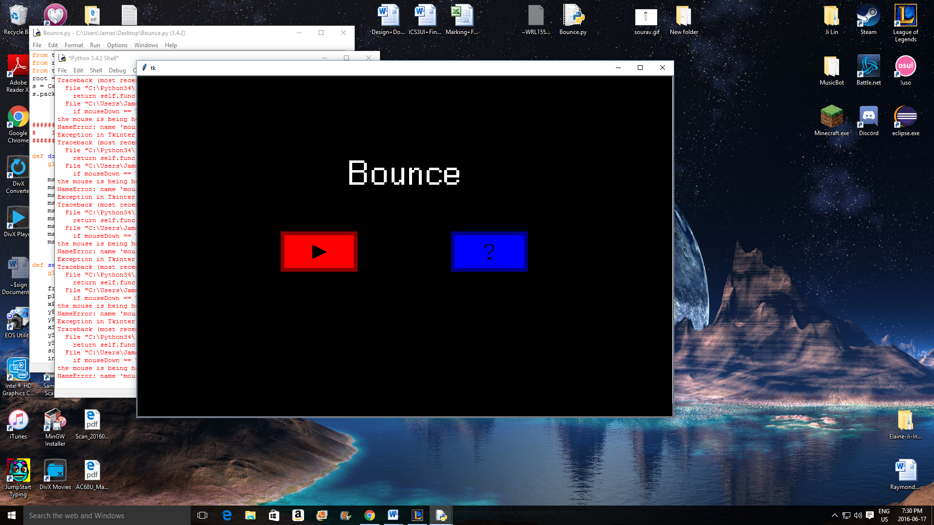

Clicking the blue help button will bring you to the first page of the help screen. Here, you will find instructions on how to play the game along with images of the scoreboard and other things in the game. In the bottom right corner, there is a button that will bring you to the second page of the help screen which contains further details about the game. The same button will also allow you to return to the first page of the help screen. When you’ve read and understood the instructions, use the home button located on the top right corner of the screen to return to the main menu.

Clicking the red play button on the main menu will bring you to the mode selection screen. On the mode selection screen, you will find four options. The options allow you to start at different points in the progression of the game. The progression of the game is in the following order, Motionless, Sideways, All Ways and Random. It is recommended that you start with Classic Mode because it allows you to get use to the motion of the ball. Upon clicking any of these buttons, the game will commence.

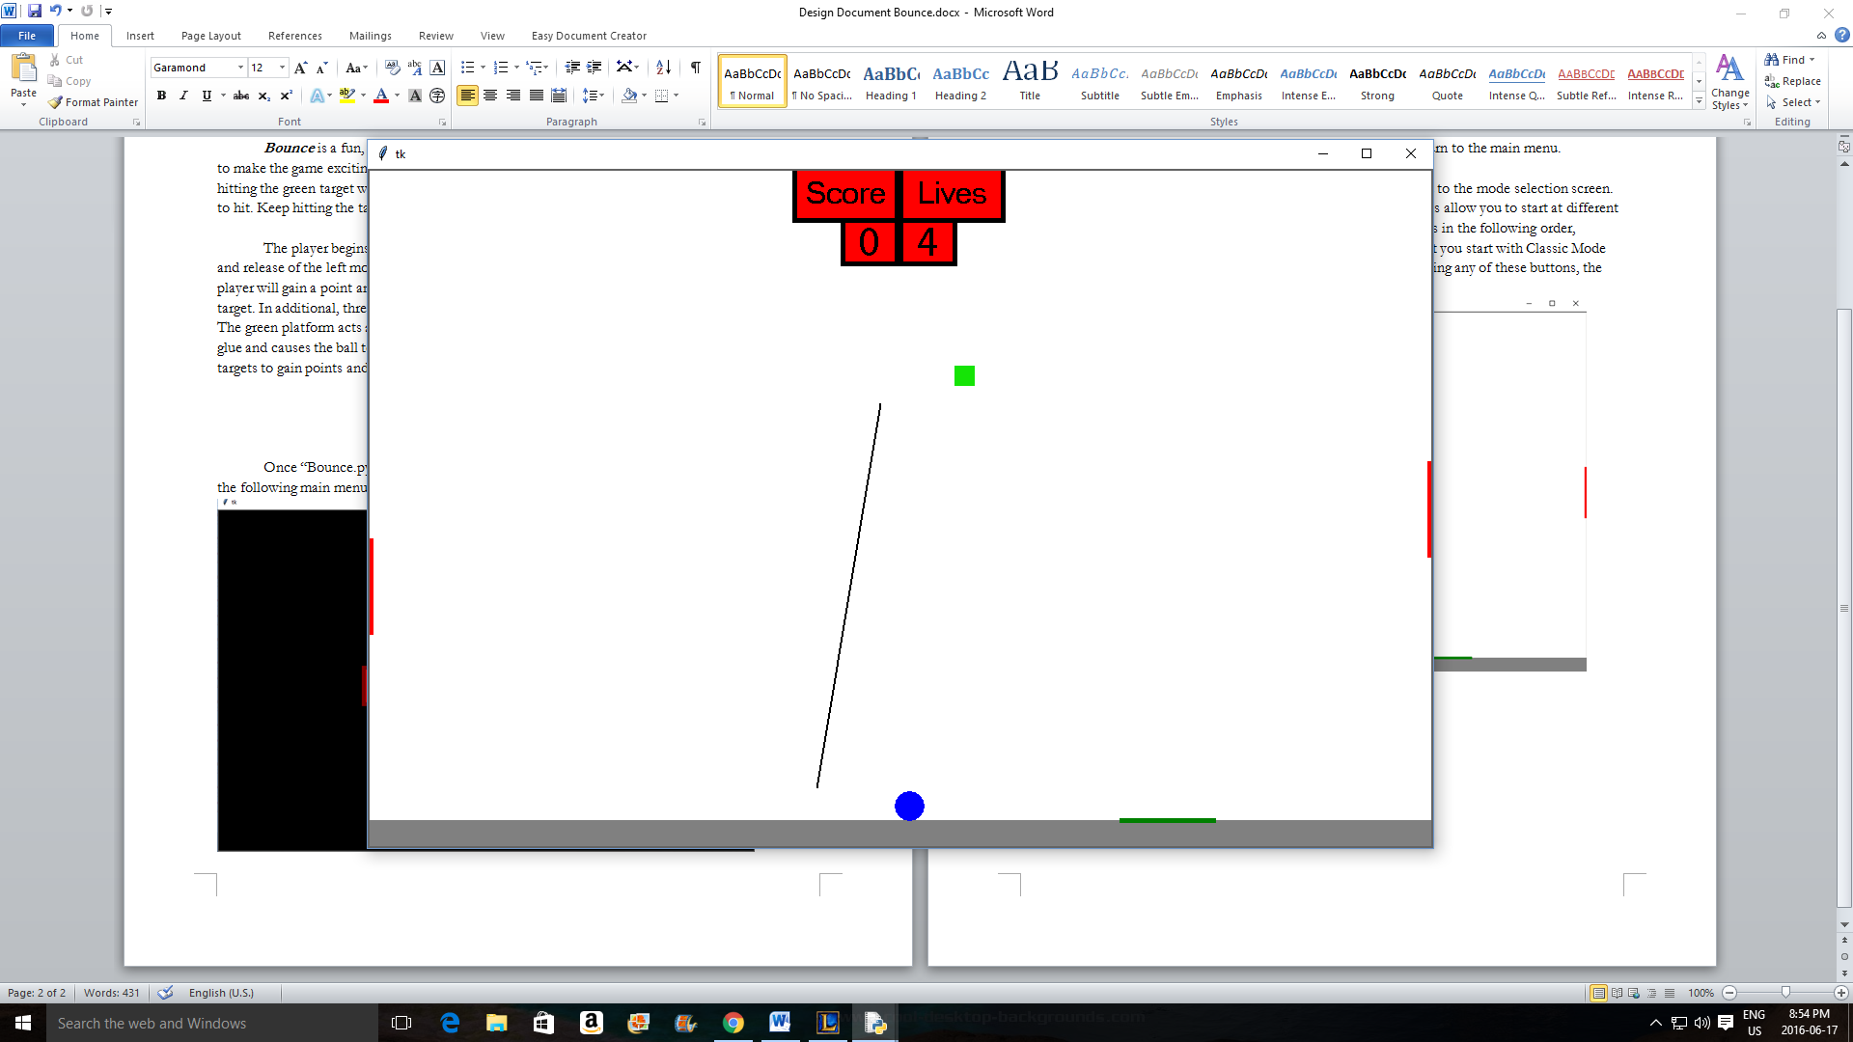

The controls of ***Bounce*** are extremely straightforward and simply. To shoot the ball, click and hold down the left mouse button in the location where you wish to start the projection line. Then, using the projection line as a guide, drag your mouse to the point where you wish to end the projection line and release. The program will then calculate the direction and speed of the ball using where you clicked and released. The only other interaction with the game is the keyboard button “Q” which will automatically close the game upon being clicked. Enjoy the game!